FEMAP API

Written By: | Mark Sherman
e-Mail: | mark.sherman@ugs.com
Date: | 6/16/2006

Written By: Mark Sherman mark.sherman@ugs.co

Title: BeamsNormalToSurface.bas

Short Description: Updates existing beam element vector orientation to be normal to a selected surface.

Detailed Description: Prompts the user to select a set of existing elements and then a single surface. Loads the surface, and then walks through each of the selected elements. If that element is a beam or a bar, the API finds the centroid, projects that point on to the selected surface, and then finds the surface normal at that point. The API then updates the beam’s y-axis to match this normal. Finally regenerates the active view.

Example:

In this model, a bulb-stiffener has been hooked to the curve running around a cylinder

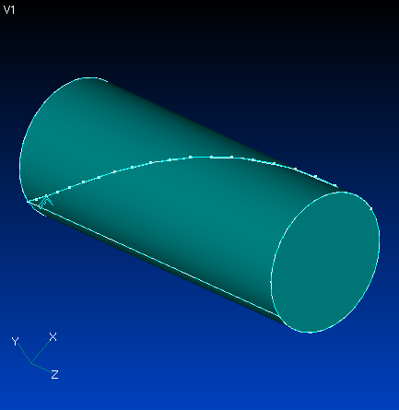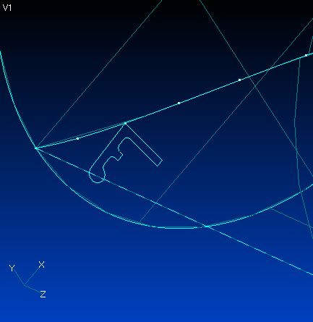

The beam “Reference Point” is used to make the cross-section ride along the curve, but only one orientation vector can be specified, resulting in the cross-section not staying perpendicular to the cylinder –
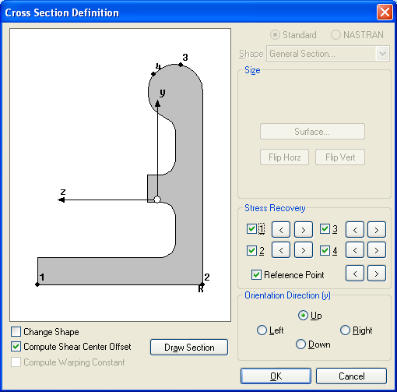
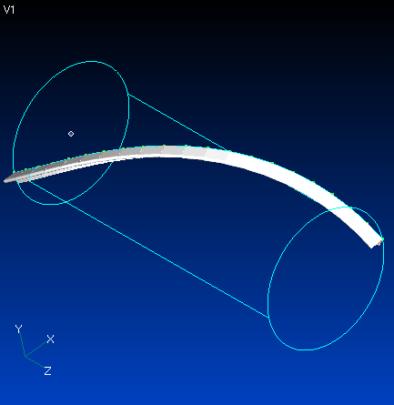

This API updates the beam elements so that they are normal to cylinder.

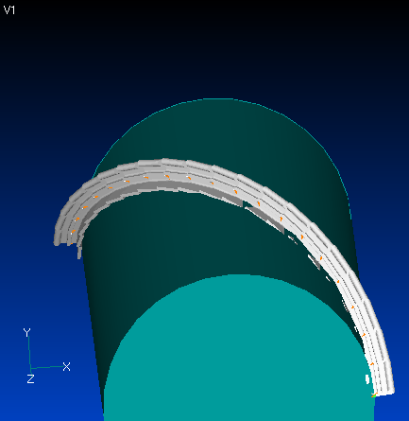

API Listing –

Sub Main
Dim App As femap.model
Set App = GetObject(,"femap.model")

Dim elSet As femap.Set
Set elSet = App.feSet

Dim nd1 As femap.Node
Set nd1 = App.feNode

Dim nd2 As femap.Node
Set nd2 = App.feNode

Dim midx As Double
Dim midy As Double
Dim midz As Double

Dim surfSet As femap.Set
Set surfSet = App.feSet

Dim surfID As Long

Dim oVec As Variant

Dim elemID As Long

Dim feElem As femap.Elem
Set feElem = App.feElem

Dim midPoint(3) As Double
Dim vmidPoint As Variant
Dim surfNormal As Variant

Dim feSurf As femap.Surface
Set feSurf = App.feSurface

Dim u As Double
Dim v As Double

rc = elSet.Select( FT_ELEM, True, "Select Beams to Re-Orient" )
rc = surfSet.SelectID( FT_SURFACE, "Select Surface", surfID )

If surfID = 0 Then
End
End If

rc = feSurf.Get( surfID )

If elSet.count > 0 Then

elemID = elSet.First()

While elemID > 0
rc = feElem.Get( elemID )
If feElem.type = FET_L_BEAM Or FET_L_BAR Then
rc = nd1.Get( feElem.Nodes(0))
rc = nd2.Get( feElem.Nodes(1))

midx = (nd1.x + nd2.x) / 2.0
midy = (nd1.y + nd2.y) / 2.0
midz = (nd1.z + nd2.z) / 2.0

' find the normal at this mid-point

midPoint(0) = midx
midPoint(1) = midy
midPoint(2) = midz

vmidPoint = midPoint

rc = feSurf.XYZToParam( vmidPoint, u, v )
rc = feSurf.normal( u, v, surfNormal )

rc = App.feModifyOrient( - elemID, 1, 0, surfNormal)
End If
elemID = elSet.Next
Wend
End If
rc = App.feViewRegenerate( 0 )
End Sub

